Year 11 BTEC Art students

Firstly, congratulations for wanting to study Art. There are so many reasons why this is a good idea. You will have the opportunity to learn new skills, work with like-minded people, go on foreign trips to look at art galleries and exhibit your work at our annual Art Show in June. At the end of the two year course, a number of our students decide to study Art, Architecture, Illustration, Textiles, Graphic Design and Photography in places like Brighton, Glasgow and London. Some decide to pursue other subjects or seek apprenticeship or employment. Whichever path you choose, studying Art can help you develop creative and critical thinking skills. It is also a lot of fun. So, what should you be doing in the run up to joining us at Paston?
The most important qualities to have as an art student are an open mind and busy fingers. The great painter Francis Bacon said ‘A painter must paint'. It is through trial and error and steady work that we begin to develop and refine our skills. Art reflects society and societies change so our thinking about art needs to be open to new ideas.
The best way to prepare for what you can expect from the course is to follow @pastonart on Instagram. You will see current work along with practical ideas for making.
At the end of each year we have an exhibition which is a great opportunity to showcase your work.
In March we go on a trip to either Amsterdam or Berlin.
So that is the course structure, here are some ideas to get you making.
Why not use some time this summer to be confined to one space in your home to focus on your surroundings?
Below is a drawing by Andrew Wyeth. Make a start by sitting next to a window with your sketchbook. Hold your pencil at arm’s length horizontally so that it is in line with your eye. Draw a delicate horizontal line on your page. You can now relate this line to what you see outside. Some things will be above, some below. Then just get cracking and enjoy making marks. In the first few weeks you will be taught some helpful approaches to understanding perspective, but at this stage, just enjoy trying to capture what you see. If you make a bold mark then that will make what you draw come forward, if you press more lightly it will recede into the distance. See how Lucinda Rogers uses a different weight of line to capture the road receding away from the viewer. So, try not to make all your marks a uniform thickness or weight. Once you get started why not make a book that documents your new confined environment. Remember the most important thing is to keep active and creative. There are some fantastic resources online. Start with Isolation Art School. I look forward to working with you all.
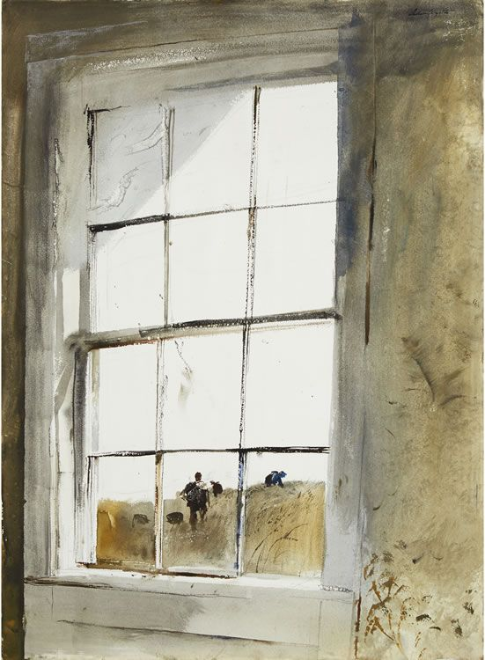
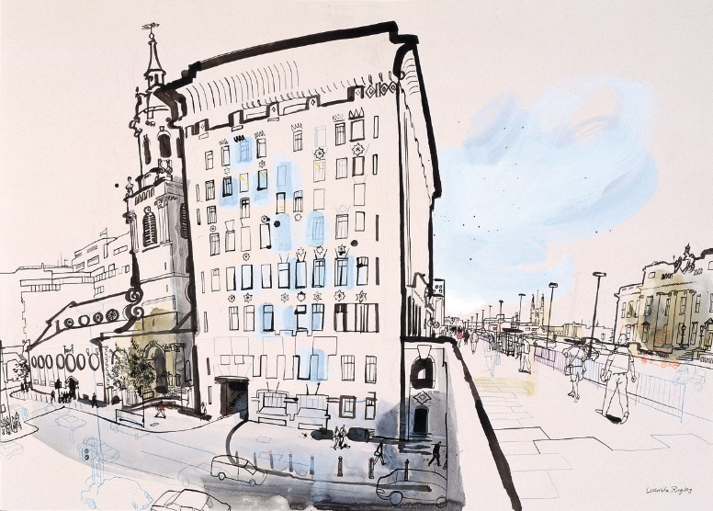

Lucinda Rogers
Andrew Wyeth

