A Level Biology

Hello and welcome to A level Biology at Paston! I am looking forward to meeting you in the new academic year. Now you have finished your GCSE course you may be wondering what you could do to prepare for A level biology and how you can stay engaged in learning. Below are some ideas that should help you to bridge the gap from GCSEs to A level. They are entirely optional, you may want to complete one or two, or perhaps all of them. If you want to contact me with any specific questions about the course then my email address is susan.crossley@ccn.ac.uk .
Good luck!
Susan Crossley

- Our exam board is Eduqas (a branch of WJEC). You can find a link to the specification here
A level specification template (eduqas.co.uk)

- A useful book to buy and look at is the CGP guide ‘Head Start to A-Level Biology’. This costs £4.95 from Amazon. Can also be purchased direct from CGP.
It summarises a lot of the content and core concepts from year 1 of the course.
https://www.amazon.co.uk/Head-Start-level-Biology-Level/dp/1782942793/ref=sr_1_1?crid=3IJT0Z4NDQ0BN&keywords=head+start+to+a+level+biology&qid=1657536815&sprefix=head+start+to+a+level+biology%2Caps%2C79&sr=8-1

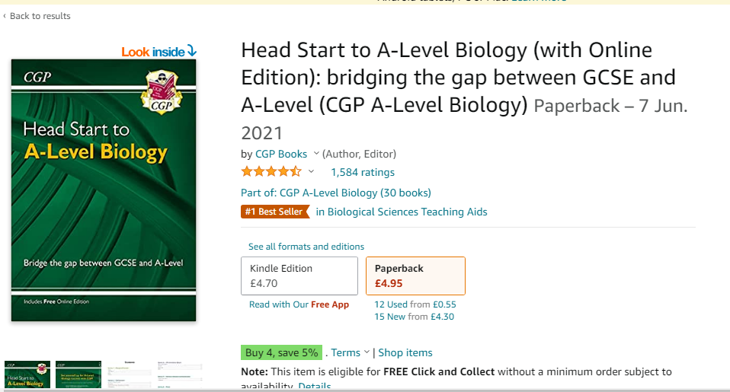

- There are some excellent you tube channels aimed at the A level syllabus
  - The Crash Course Biology videos presented by Hank are good (his brother presents history videos). You may want the subtitles on – he speaks very quickly!
https://thecrashcourse.com/courses/biology
The video on animal cells might be a good starting point as that is our first topic:
Eukaryopolis - The City of Animal Cells: Crash Course Biology #4 - YouTube

  - Paul Anderson’s podcasts for Bozeman Science are also informative
http://www.bozemanscience.com/ap-biology
You could look at his video on endosymbiosis and the work of Lynn Margulis
http://www.bozemanscience.com/endosymbiosis

- If you want something a bit more general the BBC have some excellent documentaries you can look at on iplayer
https://www.bbc.co.uk/iplayer/categories/science-and-nature/featured
Anything by David Attenborough is very watchable but there are lots of other films on there too. The Blue Planet II documentaries are excellent particularly the last one which addresses how human activity is threatening the biodiversity of the oceans
BBC iPlayer - Blue Planet II - Series 1: 7. Our Blue Planet

- If you would like to carry out some research on the internet then the following may provide a starting point;
  - Evaluate the causes of the decline in the nightingale population in the UK
  - Compile a fact file on the characteristics of the coronavirus (eg its structure, lifecycle etc)
  - Investigate the use of genetically engineered milk in cows and goats to produce pharmaceuticals (eg blood clotting factors)
  - Research the link between TB, cows and badgers
  - What is Ricketts and why are cases increasing in the UK?

You can produce work for your own satisfaction, or if you like you can email it to me or bring it in at the start of the course

