Business A-Level Preparation Pack – Paston College
Teachers – Andrina Ridgwell andrina.ridgwell@ccn.ac.uk
Vanessa Woolston oliver.mackenzie-smith@ccn.ac.uk

Exam Board – AQA
https://www.aqa.org.uk/subjects/business/as-and-a-level/business-7131-7132

Welcome to A-Level Business! You have made an excellent choice to study Business at A-Level, it opens so many doors and is the start to whatever you want your journey to be. If you enjoy using figures and statistics, problem solving, expressing your views through debating, looking at the business world in a more analytical sense and evaluating the impact business theories can have on the business environment- then this is the course for you!
In the first year of the business course you will look at the ‘foundation blocks’ of a business, the key functional areas that work together in order for a business to be successful and how the external environment impacts them. The first year is split into six units:
- What is a business?
- Managers, leaders and decision making
- Marketing
- Operations
- Finance
- Human Resources
In order to help you prepare for the first year on your A-Level Business course at Paston the following tasks have been designed to give you a flavour of what each unit covers and how the external environment impacts everything they can/want to do.

Below is a list of useful websites you may want to use for your research, but there are plenty more:
http://www.bbc.co.uk/news/business/
http://www.theguardian.com/uk/business
http://uk.reuters.com/business
http://www.businessweek.com/
http://www.economist.com/
http://www.tutor2u.net/
If you have any questions, then please contact either of us on the email addresses at the top of this page. We look forward to seeing you in September.

Task 1 (Unit 1)– Different Business Forms
There are several types of forms (ownerships) that a business can have. These range from the business being owned by one person to being owned by thousands of people.
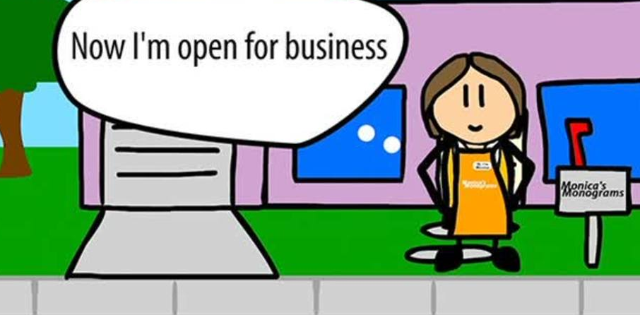
The main types of ownerships are:
- Sole traders
- Partnerships
- Private Limited Company (Ltd)
- Public Limited Company (Plc)
- Franchise
- Co-Operatives
- Mutual’s
- Charities
- Public Sector Businesses (owned by the Government)
Activity
Produce a PowerPoint presentation or a leaflet which explains and contains the following for each of the different types of ownership:
- An explanation of the type of ownership (how many people own it, how easy is it to set up, when is it mostly likely to be used, any particular requirements it must have? Etc)
- Examples of businesses with this type of ownership
- Advantages to the type of ownership
- Disadvantages to the type of ownership
- Whether they have limited or unlimited liability

Task 2 (Unit 2)– Leadership Styles
Leadership style is the manner and approach of providing direction, implementing plans, and motivating people. As seen by the employees, it includes the total pattern of explicit and implicit actions performed by their leader (Newstrom, Davis, 1993).
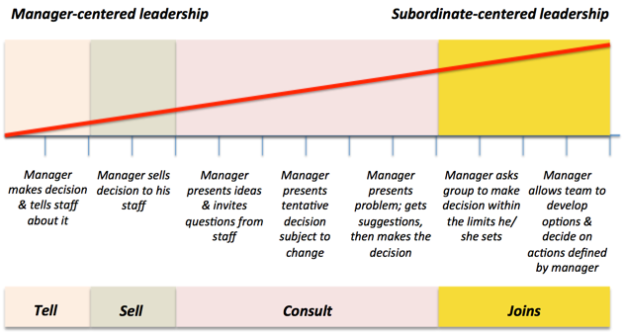
One of the leadership theories you will look at on the course is the Tannenbaum and Schmidt theory.

According to this theory, there are four main types of leadership styles a manager/leader can adopt (see diagram above).
Activity
Research this theory and the four types of leadership style it contains, along with business leaders that are considered to have this style (i.e. Alan Sugar, Richard Branson, Anita Roddick, James Dyson, Steve Jobs, Mark Zuckerberg etc).
Produce a poster for each type of leadership style that contains:
- An explanation of the leadership style
- Advantages of the leadership style
- Disadvantages of the leadership style
- An example of a business owner that is considered to have this leadership style
- Evidence/explanation as to how they fit into this leadership style

Task 3 (Unit 3) – Marketing Mix

Marketing is not just the element of advertising that we all immediately think about, it covers all elements from setting the business objectives, conducting market research, segmenting and targeting the right customers through to marketing the product or service.
Each element is important in ensuring the success of a business and its product/service portfolio, it is a culmination of these factors that allows the business to create the best marketing mix for its products/services.
Traditionally the marketing mix is identified as the 4 Ps (Product, Price, Place and Promotion) and was used due to a predominately product based need of consumers however as the service sector grew and they become more aware of the need for marketing the mix was extended to 7 Ps, adding People, Process and Physical Environment.
Below is a brief outline of what the terms mean and include:
- Price – How much the customer pays for the product/service and includes pricing strategies such as: skimming, penetration, psychological, cost-plus, loss leader and others
- Product – The product/service the customer buys and includes elements such as: the design, technology, usefulness, convenience, value, quality, packaging, branding, accessories, warranties
- Place – How the product is distributed to the customer, whether this is through: retail, wholesale, mail order, internet, direct sales, peer-to-peer or multi-channel
- Promotion – How the customer is found and persuaded to buy, this includes: special offers, advertising, endorsements, user trials, direct mailing, leaflets/posters, free gifts and more
- People – The people who contact the customers in delivering the product/service and includes: employees, management, customer services and others
- Process – The systems and processes that deliver a product/service to a customer: very important to the service industries and includes how the product/service is consumed
- Physical environment – The elements of the physical environment the customer experiences and includes location, appearance of building/interiors/staff and others

Within the Product element each item created or delivered as a service by businesses will go through what is called the Product Life Cycle – this allows the organisation to monitor their products through different stages and act where necessary to remain competitive and active within their markets.

Activities
Watch the video on the following link and make notes: https://youtu.be/ob5KWs3I3aY, then do the following:
- Explain what the Product Life Cycle is and the advantages/limitations of the process, in your own words
- Explain what each stage of the Product Life Cycle is and include examples of various products you believe are currently at each stage (You can draw a diagram to help)
- Looking at Apple’s current position of the iPhone, you have been tasked to come up with a plan to reignite the sales of the phone. You need to think of 1 or 2 extension strategies that will take them back to the growth stage. State why you recommend this action.

Businesses can look to categories their products/services from their position on in the Product Life Cycle using a model called the Boston Matrix – this is a very popular model which helps them to effectively analysis their portfolios of businesses and brands. The model categorises the brands into for quadrants based on:
- Market Share – How much of the market does that product/brand have over its competitors
- Market Growth – Is the number of potential customers growing or not?

Watch the video on the following link and make notes: https://youtu.be/JrQfcVoNXvA, then do the following:
- Using the diagram on the next page and the Coca-Cola products below (you will need to do a bit of research), put them into the most appropriate quadrant.
- Coca-Cola Classic
- Coke Zero
- Sprite
- Powerade

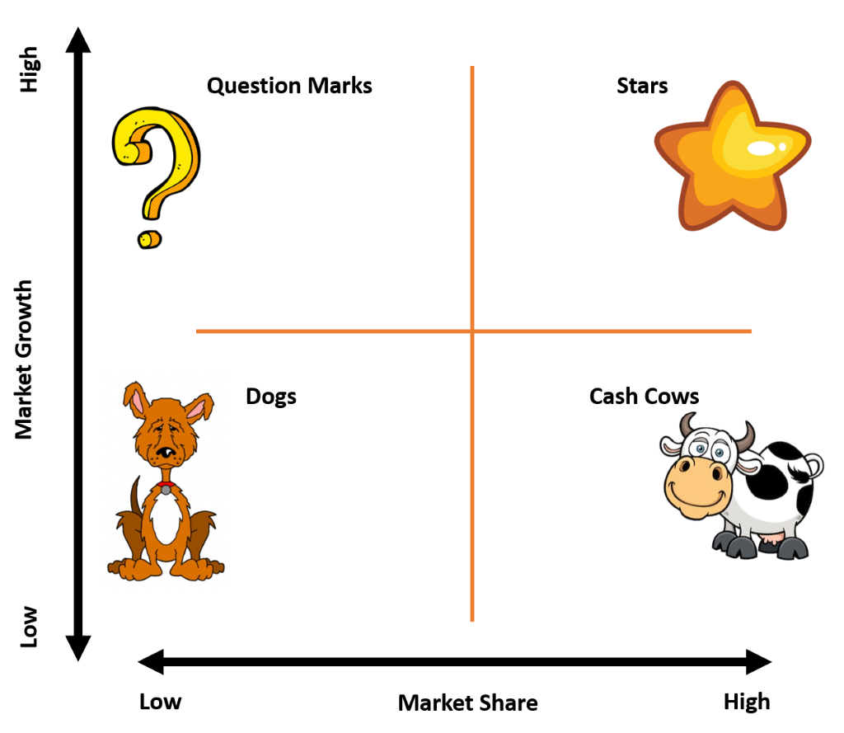

Task 4 (Unit 4) – Operations
The operations function of a business is the ‘engine-room’, and like all engines, performance can and should be measured to ensure the business is working effectively and efficiently. One way to do this is to set and monitor objectives, these include but aren’t limited to costs, efficiency, volume and environmental.

This can be affected by both internal and external influences and it is therefore important for a business to maintain effective use of its assets in order to set, plan, monitor and amend these. One of the objectives being volume puts the focus on production and the capacity of the business to achieve the highest level of output they can manage – this being ‘productivity’. They think about the cost, the production line and how this is operated – is it labour (people) or capital (machinery/technology) intensive? and how much these methods cost.

The focus is on how much each item or ‘unit’ costs to make and the lower the cost the more efficient and in turn profitable they can be. There are various ways for a business to improve this productivity, one of these being to incorporate technology into the workplace.

Activities
Read the article and watch the videos on Amazon (plus any other relevant ones of your choosing) and how they use the Robots in their warehouses:
- https://www.aboutamazon.com/amazon-fulfillment/our-innovation/what-robots-do-and-dont-do-at-amazon-fulfillment-centers/
- https://youtu.be/OC23afQmYX4
- https://www.youtube.com/watch?v=d7J2_vr0ra4

Then answer the following:
- What are the main reasons for Amazon using robots in their warehouses? (Justify your reasons)
- How does using robots help them to become more efficient and therefore productive?
- Identify and explain at least 3 advantages and disadvantages of a business choosing to incorporate technology into their production lines?

Task 5 (Unit 5) - Sources of Finance
“In order to make money, you have to have money”.

Businesses will often need to obtain finance in order to carry out their aims/activities, i.e. when investing in new technology, when they want to open new stores etc.

Activity
Research the different sources of finance available to businesses and complete a table similar to the one below.
1. Give a description for each of the sources of finance
2. Give at least 3 advantages and disadvantages for each source of finance
3. State whether it is a short-term or long-term source of finance
4. Give an example of when a business would use that source of finance (i.e. when a business wants to expand its retail outlets and purchase more, they would most likely use a mortgage in order to buy the new premises as a mortgage is a loan specifically used to buy buildings and land)
 | Description | Advantages | Disadvantages | Short or long term? | When would it be used?
Internal
Retained profit
Net current assets
Sale of assets
External
Owners capital
Loans
Crowd funding
Mortgages
Venture capital
Debt factoring
Hire purchase
Leasing
Trade credit
Grants
Donations
Peer-to-peer lending
Invoice discounting

Task 6 (Unit 6) – Human Resources
Business have a wide choice of tools to help them motivate their work force. A motivated work force will work more effectively and will be more loyal. Effective and loyal employees can help to cut costs and maintain sales in the business.
There have been several theories over the years as to what motivates a work force and how to motivate a work force. These include:
- Maslow’s Hierarchy of Needs
- McGregor’s Theory X and Theory Y workers
- Hertzberg’s Two Factor Theory
- Mayo’s Hawthorne Experiments
- Taylor’s Theory of Motivation
Activity
Produce a timeline for motivational theories, that includes at least those mentioned above but can include more, that identifies:
- The main concepts of the theory
- A diagram to help represent the theory
- The advantages and disadvantages of the theory
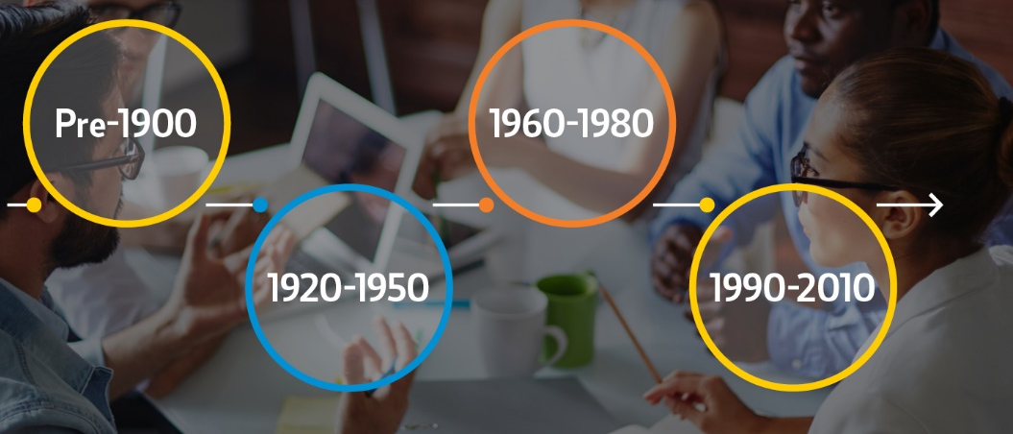
- What the main developments/differences/extensions are compared to the theory that came before it.

Be as creative as you can with the presentation of your timelines!

Task 7 (Across all Units) - External Factors
The external environment compromises those external forces that can influence a business’s activities. ​These forces are unpredictable and can change suddenly without warning​. External factors have the power to affect a business’s activities in a number of ways – both positive and negative.

The main external factors a business needs to be aware of fall into the following categories:

Political (such as an increase in Living Wage/National Minimum Wage, a decrease Corporation Tax, an increase in Income Tax, Unemployment Rates)
Economical (such as interest rates, inflation, VAT, exchange rates)
Social (such as an increasing population, an aging population, increase in migration)
Technological (such as robotics, e-commerce, social media, automation)
Environmental (such as fair trade, CO2 emissions, recycling, social responsibility)
Legal (such as 5p carrier bag tax, sugar tax, single use plastic legislation the government is bringing in)
Competition (such as new competition, the amount of competition, takeovers/mergers)
Activity
Choose a business of your choice and produce a leaflet that explains how at least one element from each of the external factors listed above has (or will) impact them. This impact can be positive or negative.

