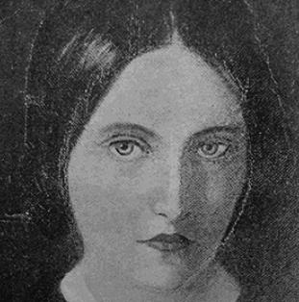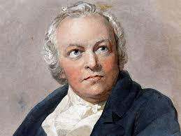

**Shut Out**

The door was shut. I looked between  
Its iron bars; and saw it lie,  
My garden, mine, beneath the sky,  
Pied with all flowers bedewed and green:

From bough to bough the song-birds crossed, 5  
From flower to flower the moths and bees;  
With all its nests and stately trees  
It had been mine, and it was lost.

A shadowless spirit kept the gate,  
Blank and unchanging like the grave. 10  
I peering through said: 'Let me have  
Some buds to cheer my outcast state.'

He answered not. 'Or give me, then,  
But one small twig from shrub or tree;  
And bid my home remember me 15  
Until I come to it again.'

The spirit was silent; but he took  
Mortar and stone to build a wall;  
He left no loophole great or small  
Through which my straining eyes might look: 20

So now I sit here quite alone  
Blinded with tears; nor grieve for that,  
For nought is left worth looking at  
Since my delightful land is gone.

A violet bed is budding near, 25  
Wherein a lark has made her nest:  
And good they are, but not the best;  
And dear they are, but not so dear.

Christina Rossetti (1862)

**The Garden of Love**

I went to the Garden of Love,  
And saw what I never had seen:  
A chapel was built in the midst,  
Where I used to play on the green.  
  
And the gates of this Chapel were shut,  
And ‘Thou shalt not’ writ over the door;  
So I turned to the Garden of Love,  
That so many sweet flowers bore.  
  
And I saw it was filled with graves,  
And tomb-stones where flowers should be,  
And priests in black gowns were walking their rounds,  
And binding with briers my joys and desires.

William Blake (1794)