ENGLISH LITERATURE

Some suggestions for pre-course reading

If you’re reading this, you’ve probably chosen to take English Literature as one of your A-Levels at Paston College in September this year. So many congratulations on choosing so wisely, and thanks - because, without you, I’d be out of a job.

In your first year of A-Level study you will do the following texts:

- Mohsin Hamid, The Reluctant Fundamentalist

- William Shakespeare, Twelfth Night
There are loads of different editions of Shakespeare’s plays and I don’t really mind which one you use though it’s best to avoid the really cheap and cheerful ones and the Penguin edition because all the notes are (unhelpfully) at the back. The following are all excellent:
- Arden (ed. Keir Elam) £8.99 ISBN 9781903436998
- RSC Macmillan (ed. Eric Rasmussen and Jonathan Bate) £7.99 ISBN 9780230243842
- Longman (ed. John O’Connor) £9.99 ISBN 9780582365780
- Oxford University Press (ed. Roger Warren) £7.99 ISBN 9780199536092
Copies of the Arden edition will be available to use in the lessons; all line references in handouts will to be this version.

- Christina Rossetti, Selected Poems (including ‘Goblin Market’)
You don’t need to buy a book for this; instead the poems are available via Blackboard, the college’s virtual learning environment, and you just print them off for each lesson.

- Jhumpa Lahiri, The Namesake

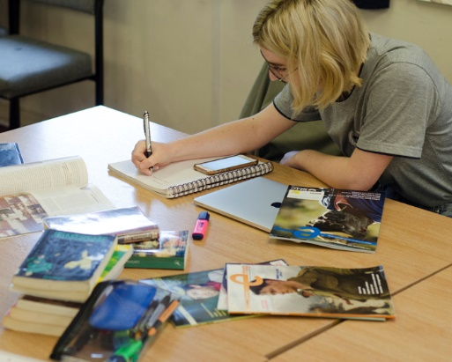
If you want to get ahead, may I suggest you read the two novels? Neither is ‘difficult’ as such, but both are hugely engaging and rewarding reads if in interestingly different ways. There’s only one edition of each text: The Reluctant Fundamentalist is published by Penguin, The Namesake by 4th Estate.

At this point, I’d really like to emphasize something about reading. Students who do well on this course don’t necessarily turn up having read loads of books. Many may just be familiar with the texts they studied at GCSE. And this is completely fine! The most successful English Lit students are interested in the world, in society and the ways it functions, and above all, in people and how they behave. What we study in English Literature is the ways writers use language to offer different perspectives on the world and the people in it. An engagement with life and with language is absolutely key; having read a lot of books is not. English Literature is not and never will be a reading competition.

That said, if you fancy reading something good over the summer, here are ten suggestions to stimulate, entertain and inspire …

Neil Astley (ed.), Staying Alive
A wonderful anthology of mostly contemporary poetry; just dip in and out, finding poems which take your fancy. There are two other anthologies edited by Astley – Being Alive and Being Human – which are equally good.

Margaret Atwood, The Handmaid’s Tale
As horribly relevant now as it was when Atwood first published it in 1985.

Emily Bronte, Wuthering Heights
Is there a more overwhelming love story in English Literature? It’s intense, exciting, violent, romantic and contains the ultimate outsider figure in the brooding Heathcliff. As much about social injustice and the power of property-ownership as it is about love, once read it’s never forgotten.

Angela Carter, The Bloody Chamber
A glittering collection of short stories, all based on traditional folktales. Carter ingeniously reveals their latent eroticism and violence in writing which is as beautiful as it is dangerous.

Robert Eaglestone, Doing English
This is the only critical book included in this list but it’s a cracker. It will get you thinking about what it means to study English and why it’s important to do so.

F. Scott Fitzgerald, The Great Gatsby
It’s a crime novel, a romance, a buddy narrative, an almost documentary description of life in New York in the 1920s Jazz Age, and yet so much more. All this and Fitzgerald’s deathless prose - you can’t go wrong with The Great Gatsby.

James Joyce, Dubliners
Joyce has a fair claim to be the most influential and important prose writer of the last century. This is his first book, a collection of short stories about his native Dublin, most of which were written while he was in exile in Europe. And they are amazing: written with an incredible, spare beauty, great humanity, and generous psychological insight. There are a couple you might want to avoid (‘Ivy Day in the Committee Room’ has never done much for me) but don’t, on any account, miss out on ‘The Dead’, ‘The Boarding House’, ‘A Painful Case’ or ‘Eveline’.

Hanif Kureishi, The Buddha of Suburbia
The funniest, rudest, most provocative coming of age novel I know. Karim, ‘an Englishman born and bred, almost’, is growing up in the suburbs of 70s London and ‘looking for trouble …’

Maggie O’Farrell, Hamnet
Hamnet was Shakespeare’s son who died at the age of 11. This is partly his story but, mostly, it’s the story of his mother, Agnes, free-spirited, unconventional, maybe possessed of magical powers. Hamnet’s dad is marginal figure in the novel but it ends with a visit to London and a performance of maybe the most famous play in western literature. Hamnet is about family, grief, and how one helps to overcome the other. It really is a beautiful thing and, post-pandemic, astonishingly resonant.

Zadie Smith, White Teeth
Mostly written while Smith was a student at Cambridge, this is a wonderful, entertaining and exuberant novel about race, class, life in the city, and teeth!

Final details:

We do the OCR specification which you can look up here if you want to: https://www.ocr.org.uk/qualifications/as-and-a-level/english-literature-h072-h472-from-2015/

If you want to contact me, feel free to; my email address is george.norton@ccn.ac.uk.

