Geography and Environmental Science in the summer holidays!
Just cause it’s the summer holidays doesn`t mean that your Earth Science education stops! There are loads of things you can do over the holiday to peek your curiosity and develop your wider knowledge.
Keep a note of what you do and what you found interesting. I`d like to hear once you return in September.

FREE online courses or seminars
CAT is the Centre of Alternative technology in Wales. They often run webinars and courses covering all sorts of environmental issues. Here are some past webinars you can listen too. They are very useful for geographers and environmental science students alike.
https://cat.org.uk/past-webinars/#climatejustice (climate justice)
https://cat.org.uk/past-webinars/#water (teaching people how live with a lower impact on the climate)
https://cat.org.uk/past-webinars/water-systems-sky-to-sea/ (a virtual tour of the water cycle)
https://cat.org.uk/past-webinars/looking-to-restore-ecosystems-observations-from-above/ (using satellite data to restore ecosystems)

FutureLearn provides some FREE online courses on loads of different subject areas. Courses are designed to take a few hours over 2 to 4 weeks. A small fee applies of you want to print off a certificate of achievement. Take a look!
https://www.futurelearn.com/courses/ecology-and-wildlife-conservation 2 hrs X 2 weeks
https://www.futurelearn.com/courses/life-below-water-biodiversity-ecology-human-impacts-and-solutions 3hr X 4 weeks
https://www.futurelearn.com/courses/gender-and-development 3hrs X 2 weeks

Wider Reading
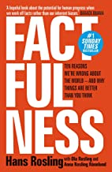

Factfulness: Ten Reasons We're Wrong About The World - And Why Things Are Better Than You Think
by Hans Rosling , Ola Rosling , et al. | 3 Apr 2018

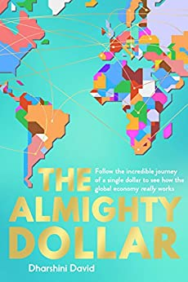

The Almighty Dollar: Follow the Incredible Journey of a Single Dollar to See How the Global Economy Really Works

by Dharshini David (Author)

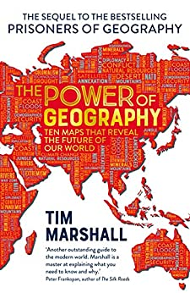
The Power of Geography: Ten Maps That Reveal the Future of Our World
by Tim Marshall

TV Programmes on iplayer
https://www.bbc.co.uk/iplayer/episode/m0007znv/china-a-new-world-order-series-1-episode-1 China – A New World Power. Great for the Powers and Borders topic in geography
https://www.bbc.co.uk/iplayer/episodes/p00pqbfg/indian-ocean-with-simon-reeve Journeys with Simon Reeve. His discussions with people and about places he visits are fantastic for exploring the geography of place.

