Law A Level Preparation Pack - Paston College
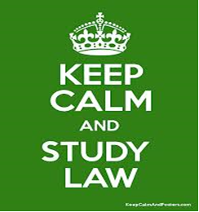
Teacher - Oliver Mackenzie-Smith
oliver.mackenzie-smith@ccn.ac.uk
Exam Board - AQA
https://www.aqa.org.uk/subjects/law/as-and-a-level/law-7162
Welcome to Law A-level! You can look forward to discussion, debate and learning more about practically all things legal and illegal. Fasten your seatbelts it’s not for the squeamish!
Textbooks: AQA A-Level Law, Book 1, Jacqueline Martin and Nicholas Price, published by Dynamic Learning and Hodder Education (ISBN 978-1-5104-0164-8); AQA A-Level Law Book 2, by Jacqueline Martin, Nicholas Price and Richard Wortley, published by Dynamic Learning and Hodder Education (ISBN 978-1-5104-0174-7). We will use both books years 1 and 2.
SUMMARY OF SUBJECT CONTENT AND ASSESSMENT
AQA A Level LAW

The nature of law and the English legal system
The nature of law will include the study of the distinction between enforceable legal rules and principles and other rules and norms of behaviour; criminal and civil law and the different sources of law (including custom, statutory law and the common law). Students must also show knowledge and understanding of the rule of law and law making; and the legal system including court and tribunal structures and legal personnel.

Criminal law
Study to include the rules of criminal law and general elements of liability. Students will learn about both non-fatal and fatal offences against the person; and also property offences such as theft and robbery. Capacity defences of insanity and intoxication and necessity defences of self-defence, duress, and duress of circumstances will be covered also, and finally the preliminary offences of attempt.
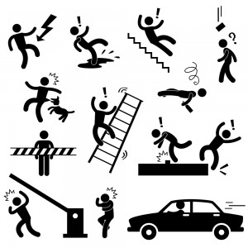
Tort
Students must know the rules of the law of tort, including liability in negligence for injury to people and damage to property. In addition we will look at duties owed under the two Occupier’s Liability Acts for both lawful visitors and trespassers. Remedies to a Tort action are covered encompassing compensatory damages and mitigation of loss and injunctions. Torts connected to land (law of nuisance and Rylands v Fletcher) and Vicarious liability will be studied and finally defences to a claim, including contributory negligence and volenti non fit injuria. Yes, we learn some Latin!

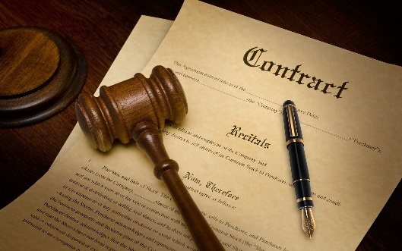
Law of contract
This unit will start with the rules and theory of the law of contract, and the essential requirements of a contract. Topics covered will include express and implied terms, conditions, warranties and innominate terms, exclusion and limitation clauses, misrepresentation and economic duress. Discharge of contract including breach of contract, performance and frustration will be studied alongside remedies including damages and equitable remedies

Assessments
 | Paper 1 | Paper 2 | Paper 3
What’s assessed | - The nature of law and the English legal system.  - Criminal law. | - The nature of law and the English legal system.  - Tort. | - The nature of law and the English legal system.  - Law of contract.
How it’s assessed | Written exam: 2 hours  33% of A Level | Written exam: 2 hours  33% of A Level | Written exam: 2 hours  33% of A Level
Questions | A combination of multiple choice, short answer and extended writing questions.

In the first year, we will cover Paper 1 and part of Paper 2 so your prep work should focus on these.
Tasks you can complete to give you a taste of Paper 1 -
1. Create a poster demonstrating the hierarchy of criminal courts, which also reflects the appellate routes from Magistrates Court to the Supreme Court.
- Within your poster explain what types of cases these courts can hear, such as summary, triable either way and indicatable offences.
- Come up with a few examples for each.
- Include descriptions of the different types of judges and legal personnel involved in the court system.
2. Complete a research project on Sentencing. What are the aims of sentencing? What powers do the criminal courts have regarding punishment?
- Click on the link https://sentencingcouncil.org.uk/crown-court/
- From this link, choose your own criminal offence and include the sentencing guidelines, define aggravating and mitigating factors and include some of those to be considered for your chosen crime.
3. Click on this link http://e-lawresources.co.uk/Criminal.php and research the following cases:
- DPP v Majewski
- Fagan v MPC
- DPP v K
- R v Constanza
- Collins v Wilcock
- R v Ingils (2011)
- R v Church (1965)
- R v Clinton (2012)
- R v Cunningham (1957)
- R v Cheshire (1991)
- R v Ireland (1997)
- C v Eisenhower (1984)
4. Research the elements of a crime.
- What is the Actus Reus?
- The Mens Rea? What are strict Liability Offences?
- What is the burden of Proof and the standard of Proof in criminal and civil cases?
5. For Paper 2, we study Tort Law. The origins of Tort law are found in the classic, Donoghue v Stevenson.
Tasks for you to complete for Paper 2:
- Click on the link below to watch an entertaining recap of this key case.
https://www.bing.com/videos/search?q=donoghue+v+stevenson&&view=detail&mid=C53AD9575CBA652B0576C53AD9575CBA652B0576&&FORM=VRDGAR&ru=%2Fvideos%2Fsearch%3Fq%3Ddonoghue%2Bv%2Bstevenson%26FORM%3DHDRSC3
- Research what is a Tort?
- What is negligence in law?
- What is a Duty of Care?
- To whom is this duty owed?
- Research the following cases: Donoghue v Stevenson (1932), Blyth v Birmingham Water Works (1865) Mullin v Richards (1998) Nettleship v Weston (1971).
5. Create a poster of the Civil Court system, including the types of courts, such as the County Court, High Court and Queens Bench Division.
- What types of cases do they hear?
- Include an explanation of the three tracks - small claims, fast track and multi-track
- Include the different types of judges
Suggested Reading:
- The Secret Barrister (2018) published by Macmillan
- Landmarks in the Law (1984) by Lord Denning, published by Butterworths. (In fact anything written by the great man)
- The Rule of Law (2010) by Tom Bingham, published by Pengiun
- For purchase I recommend: AQA A-Level Law, my revisions notes, For the 2017 Specification, written by Clare Wilson and Craig Beauman. Published by Hodder Education (2018)
TV shows, radio and movies:
Classic legal dramas: To Kill a Mockingbird,12 Angry Men, Erin Brokovich, A Civil Action, The Rainmaker and recently in the cinema, Dark Waters on Netflix, You don’t Know Me and on Amazon Prime, The Escape Artist (Parts 1&2)
For your listening pleasure, listen to radio legal dramas by clicking on this link
https://www.bbc.co.uk/programmes/m000d8x4/episodes/player
TV: The classic Rumpole of the Bailey series, Judge John Deed and Silks. Although I love Suits, it’s not terribly realistic.
Finally, type “Law and Order” on the BBC news website, read about recent cases and developments in the law.

Enjoy your summer, see you soon! Any questions don’t hesitate to email me.
Regards,
Oliver
😊

