A-Level Physics
Course Preparation Tasks

Course Lecturer: Matthew Cawdron
Email: matthew.cawdron@ccn.ac.uk

Preparation Work
There are the tasks that I would like you to complete in preparation for starting the Physics course.
Isaac Physics
The work has been set on “Isaac Physics” which will be used by your teachers during your A Level
Physics studies. To access the series of questions that has been set for you either:
- Enter the following link into your web browser and follow the on-screen instructions:
https://isaacphysics.org/account?authToken=22NW4X

- Google “Isaac Physics” and set up a student account.
Under the menu, select “My account”, then “Teacher connections”
Enter the code 22NW4X to join the summer work classroom

Once you have successfully set up your account and joined the A Level Physics summer work group, if you click on “menu” then “my assignments” you should be able to see 2 assignments, that consist of smaller tasks.
Assignment 1:
1. A1 Using and Rearranging Equations
2. A3 Standard Form and Prefixes
3. A4 Converting Units
4. A5 Gradients and Intercepts of Graphs
5. A6 Equations of Graphs
6. A7 Area under the Line on a Graph
Assignment 2:
- Q: Sig fig Practice

- Q: Sig Fig Mastery
When you click on “view assignment” next to each of these, you will see a number of purple hexes. Clicking on each of these in turn will bring up a series of questions. Enter your answer into the answer box and click “check my answer”. Be careful to answer to the correct number of significant figures. Click “Back to board” to go back to the assignment and continue answering questions.
When you click on “view assignment” you may also see yellow hexes, these are guides to provide you with help if required.
If you are struggling to access the work, please feel free to email me to ask for help.
Make sure you answer all the questions for each of the assignments.
Practical Work
As part of the practical requirement, you are required to keep a lab book as a record of your work. The lab book you need to purchase is the following:
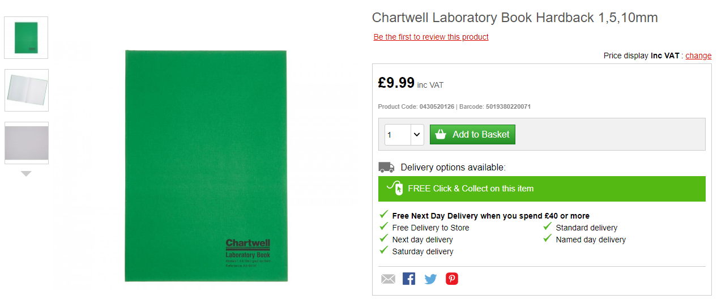
Ryman Link
Amazon Link
This will provide you with a robust lab book that will have enough space to cover both years of the course.
Optional Task
CGP has produced two books which work on skills in preparation for the study of A-level Physics. I recommend that you work through these books in preparation for the course. They have mark schemes in them for you check how you are progressing.
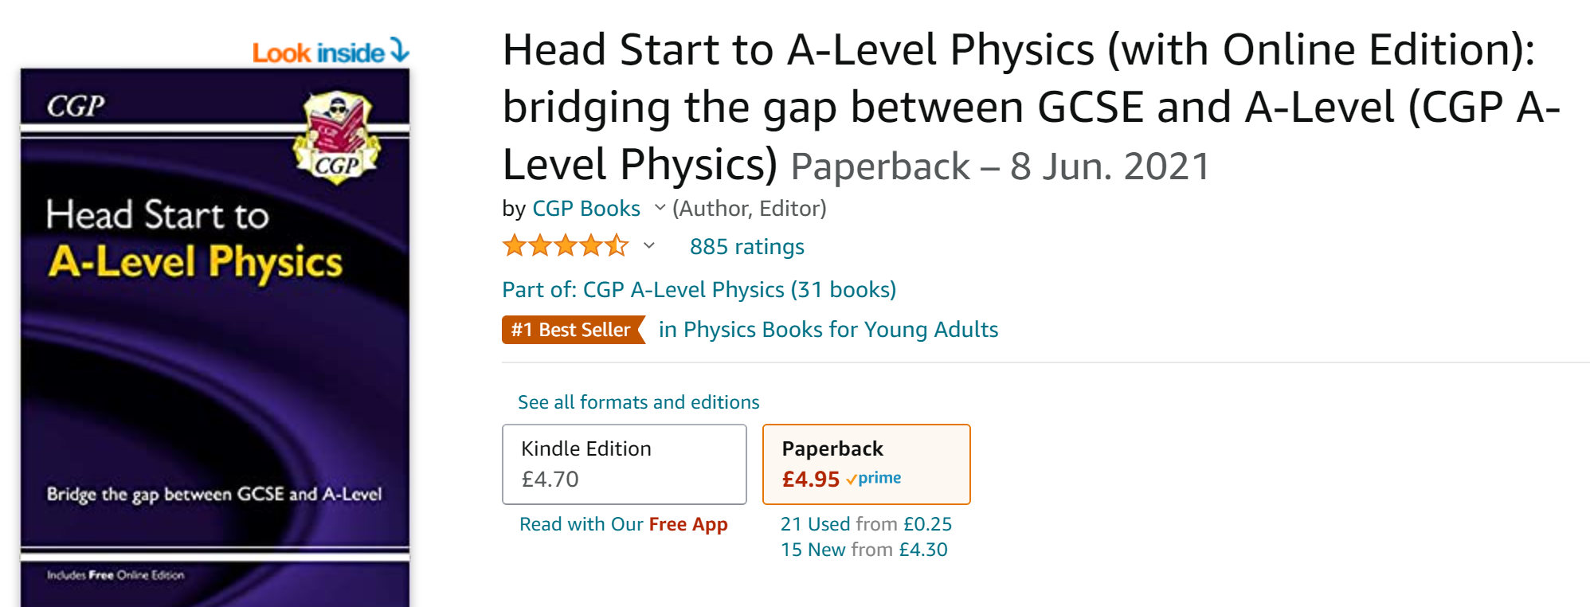
Amazon link
The other CGP book I recommend looking at focuses on the Maths skills required for the course and will then support you during the course as well:
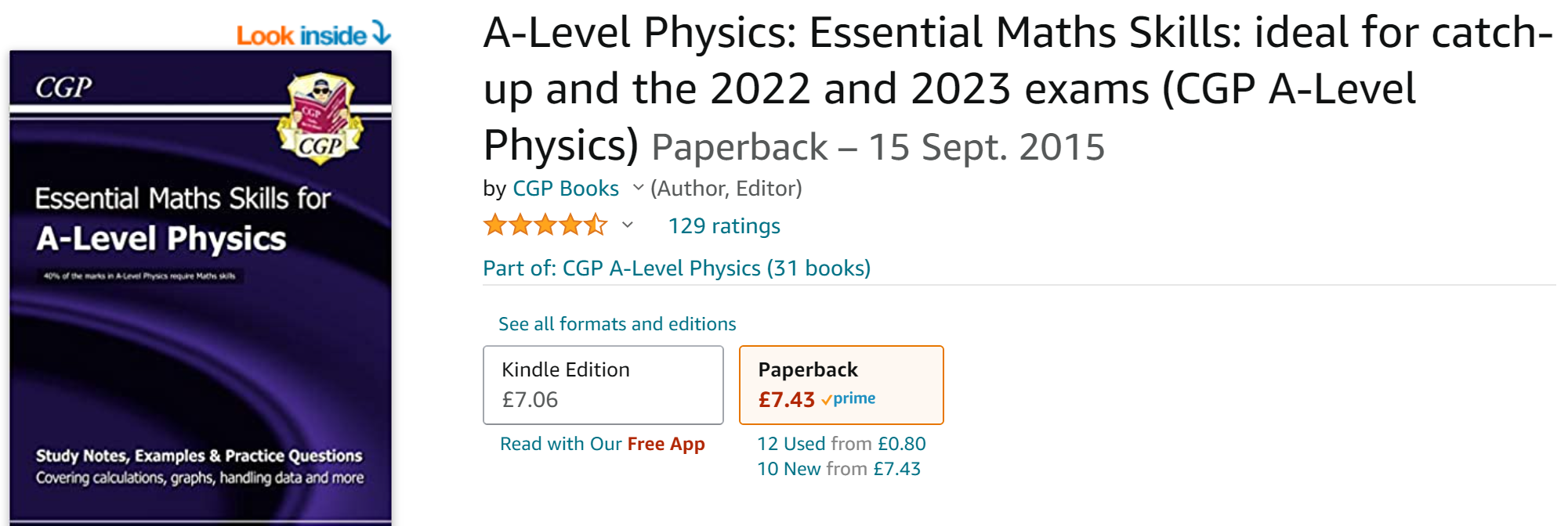
Amazon link
Purchasing of both these books is optional, but will provide you with a good basis to being study at A-level Physics.

