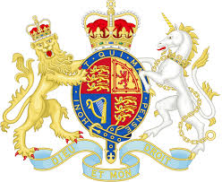

Introduction to A Level Politics (edexcel)
Paston College
2022/2023
Updated June 2022 KTH

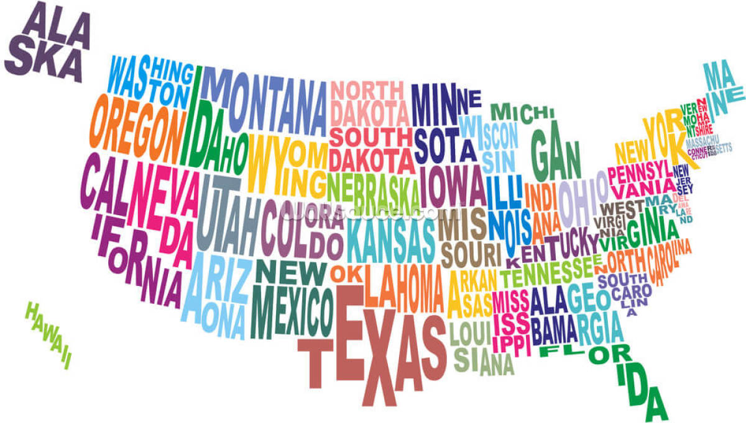

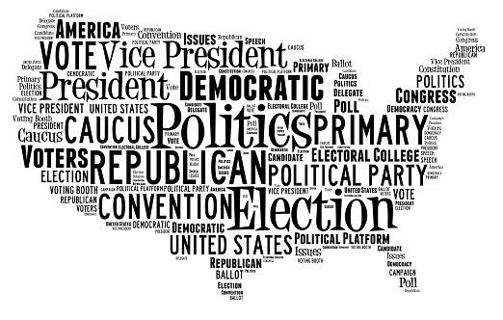
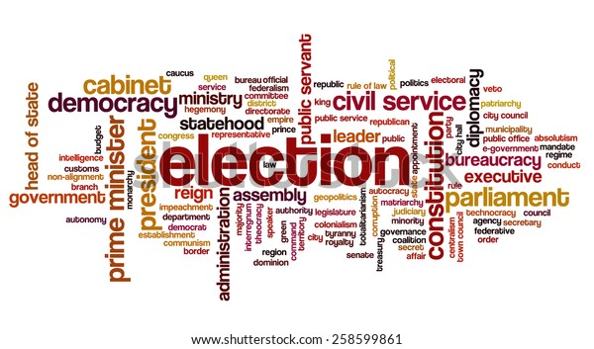
A Level Politics at Paston College
Which are the best universities to study Politics?
The Complete University Guide 2021 League Tables identified the following as the top 10 places to study Politics in the UK:
Oxford – Cambridge – St Andrews – London School of Economics (LSE)– Kings College, London – University College London (UCL) – Warwick – Durham – Bath – Strathclyde
Find more information at: www.ucas.com/explore/subjects/politics
Where can A Level Politics lead?
As well as offering the foundations for a degree in Politics, or a related field such as International Relation, in Politics A Level you will develop a range of core academic skills that will enable you to go on to many undergraduate courses. For example, you will develop excellent research skills, essay writing, evaluative and analysis skills, and a sophisticated range of specialist vocabulary. You will also be able to make comparisons between complex theories, ideologies, and practices.
Politics at Paston College
At Paston College, we study the EDEXCEL specification and study the following units:
- UK Politics, including core political ideas (Conservatism; Socialism; Liberalism).
You will learn about different types of democracy, and the role of the media on voting behaviour and electoral system.
- UK Government, including the non-core political idea of Feminism.
You will study the structure of the Government, including relationships between different branches, the role of the PM and executive and the constitution.
- Comparative Politics: USA and UK.
You will study the US constitution and Federalism, US Congress, Presidency and Supreme Court, civil rights, democracy and participation and comparative theories.
There are no controlled assessments for A Level Politics and all examinations take place at the end of year 13.
What is Politics? Politics is the study of the governance of a country, and power relations between different political parties. This includes the study of voting participation, ideologies of political parties and the way that decisions made by government impact all people in that country.
Politics at Paston College is taught by Karen Treby-Howard. If you have any questions about the course, please contact me directly via email: karen.treby-howard@ccn.org.uk
Specification: Content and assessment overview
The Pearson Edexcel Level 3 Advanced GCE in Politics consists of three externally examined papers. Students must complete all assessment in May/June in any single year.

Component 1: UK Politics (*Component code: 9PL0/01)
Written examination: 2 hours 33⅓% of the qualification 84 marks
Content overview
1. Political Participation, students will study: • democracy and participation, political parties, electoral systems, voting behaviour and the media.
2. Core Political Ideas, students will study: • conservatism, liberalism, socialism.
Assessment overview
Section A: Political Participation - One 30-mark question from a choice of two (each question uses a source) – students must complete one of these. Plus one 30-mark question from a choice of two – students must complete one of these. All questions assess AO1, AO2 and AO3.
Section B: Core Political Ideas - One 24-mark question from a choice of two, which assesses AO1, AO2 and AO3.
Component 2: UK Government (*Component code: 9PL0/02)
Written examination: 2 hours 33⅓% of the qualification 84 marks
Content overview
- UK Government, students will study: • the constitution, parliament, Prime Minister and executive, relationships between the branches.
- Non-core political ideas, students will study: • one idea from the following: anarchism, ecologism, feminism, multiculturalism, nationalism.
Assessment overview
Section A: UK Government • One 30-mark question from a choice of two (each question uses a source) – students must complete one of these. Plus one 30-mark question from a choice of two – students must complete one of these. • All questions assess AO1, AO2 and AO3.
Section B: Non-core Political Ideas • One 24-mark question from a choice of two, which assesses AO1, AO2 and AO3.
Component 3: Comparative Politics (*Component code: 9PL0/3A)
Written examination: 2 hours 33⅓% of the qualification 84 marks Students study USA (9PL0/3A) Content overview
For USA (3A), students will study: • the US Constitution and federalism, US Congress, US presidency, US Supreme Court and civil rights, democracy and participation, comparative theories.
Assessment overview for 3A
Section A • One 12-mark question from a choice of two, which assesses AO1 and AO2.
Section B • One compulsory 12-mark question focused on comparative theories, which assesses AO1 and AO2. Section C • Two 30-mark questions from a choice of three, which assess AO1, AO2 and AO3.
Getting you prepared for A Level Politics

Every lesson you must come prepared for learning with:
- Core textbook: Jenkins. S., Tuck, D and Jefferies. J., Pearson Edexcel A Level Politics (Philip Allan, 2019), ISBN: 1510449221.
- Basic stationary including lined paper, pens and highlighters.
- Completed homework tasks.
- Folder which is organised and up to date.
- You may use a laptop if you prefer. However, you must print out your work at the end of each lesson and adding it to your folder.
Assessments
You will have an assessment every two weeks. This may be a quick core knowledge task such as defining specialist terms. You will also have seen and unseen essay questions, including source questions. You will be told in advance when you will have an assessment and will be expected to prepare properly. Over the year you will be tested on a range of Assessment Objectives.
You will also have college mock exams as per the calendar.
Assessment Objectives.
AO1: knowledge and understanding of political institutions, processes, concepts, theories and issues (35% of marks).
AO2: Analyse aspects of politics and political information, including in relation to parallels, connections, similarities, and differences (35% of marks)
AO3: Evaluate aspects of politics and political information, including to construct arguments, make substantiated judgements and draw conclusions (30% of marks)
Course overview
 | Sep | Oct | Nov | Dec | Jan | Feb | Mar | Apr | May | Jun | Jul
Year 12 | Unit 1: UK Politics and Core Political Ideas |  |  |  | Unit 2: UK Government and Non-Core Political Ideas (Feminism
Year 13 | Unit 2: Comparative Politics - USA |  |  |  |  |  |  | Revision | Exams |  | Results
You will be given more detailed information about each unit of work. You can also find more information on the exam board website.

Developing your knowledge and interest in contemporary politics and current affairs: Suggestions of how to engage beyond the specification
Watch | Read
Newsnight (BBC)  Louis Theroux documentaries (iPlayer)  Thatcher and Reagan (iPlayer)  Chernobyl (HBO)  Four hours at the Capitol (iPlayer)  Blair and Brown (iPlayer)  Surviving 9/11 (iPlayer) | Online newspapers – a range of left and right wing (For example., the i vs. the Telegraph)  Ian Dale (2020) The Prime Ministers  Barak Obama (2020) A Promised Land  Simone de Beauvoir (2015 edition) The Second Sex  Introduction books by Totem Books  Reni Eddo-Lodge (2018) Why I am no longer talking to white people about race  Simon Kuper (2022) Chums
Listen | Research
Newcast (BBC Sounds)  Ukrainecast (BBC Sounds)  Any questions/Any answers (Radio 4)  Westminster Hour (Radio 4) | House of Commons: https://www.parliament.uk/business/commons/  UK Parliament: https://www.parliament.uk/  Supreme Court UK: https://www.supremecourt.uk/  The White House: https://www.whitehouse.gov/  Congress: https://www.congress.gov/  US Supreme Court: https://www.supremecourt.gov/
Helpful learning resources
Edexcel Politics website: https://qualifications.pearson.com/en/qualifications/edexcel-a-levels/politics-2017.html

Tutor2U resources: https://www.tutor2u.net/politics/reference

Study Rocket: https://studyrocket.co.uk/revision/a-level-politics-aqa - for AQA but many relevant resources

A Level Politics: https://www.alevelpolitics.com/

Summer Homework
You need to have knowledge of a range of Prime Ministers. This includes:
- When they held the position of PM

- Which
- How many seats they won in each election they won?
- Key policies
- Key events during their time in office
We will look at other Prime Ministers throughout the course, but for your summer homework I would like you to research and write a case study of each of the following people. This needs to include the points above, and any interesting or important facts you also find out.

Prime Ministers to research
- Margaret Thatcher
- John Major
- Tony Blair
- Gordon Brown
- David Cameron
- Theresa May
- Boris Johnson
