Religion Philosophy & Ethics
Summer Work Pack 2022
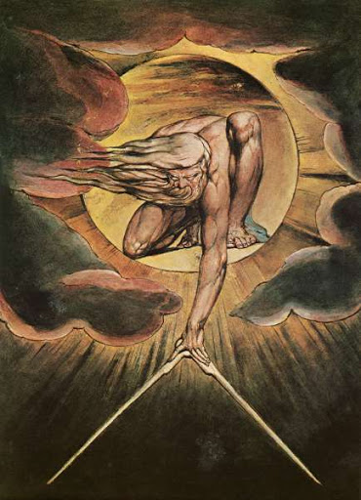

Types of Argument and Reasoning

Deductive Arguments and Reasoning
Deductive reasoning, or deduction (top-down logic), starts out with a general statement, or hypothesis, and examines the possibilities to reach a specific, logical conclusion. Deductive reasoning links premises with conclusions. If all premises are true, the terms are clear, and the rules of deductive logic are followed, then the conclusion reached is necessarily true. The scientific method uses deduction to test hypotheses and theories.
In deductive reasoning, if something is true of a class of things in general, it is also true for all members of that class. For example, "All men are mortal. Harold is a man. Therefore, Harold is mortal." For deductive reasoning to be sound, the hypothesis must be correct. It is assumed that the premises, "All men are mortal" and "Harold is a man" are true. Therefore, the conclusion is logical and true.
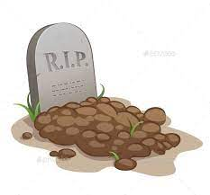

It's possible to come to a logical conclusion even if the generalisation is not true. If the generalization is wrong, the conclusion may be logical, but it may also be untrue. For example, the argument, "All bald men are grandfathers. Harold is bald. Therefore, Harold is a grandfather," is valid logically but it is untrue because the original statement is false.

Inductive Arguments and Reasoning
Inductive reasoning, also known as induction, or, informally, "bottom-up" logic, is a kind of reasoning that constructs or evaluates general propositions that are derived from specific examples. Here’s an example: "Almost all people are taller than 26 inches. Gareth is a person. Therefore, Gareth is almost certainly taller than 26 inches." Inductive arguments are concerned with probability – how likely is something to be true.
Even if all of the premises are true in a statement, it is possible, in inductive reasoning, for the conclusion to be false. The conclusion does not follow logically from the statements.

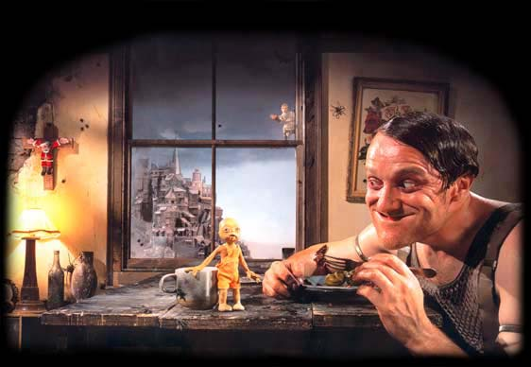

Contrast
Deductive reasoning (top-down logic) contrasts with inductive reasoning (bottom-up logic) in the following way: In deductive reasoning, a conclusion is reached from general statements, but in inductive reasoning the conclusion is reached from specific examples.

A priori statements or knowledge
A statement is considered a priori if it is true or false without the need for observation, can that be known by reason alone (prior – meaning before).

A posteriori statements or knowledge
A statement is considered a posteriori if it is true or false with the need for observation, that cannot that be known by reason alone (post – meaning after).

Example

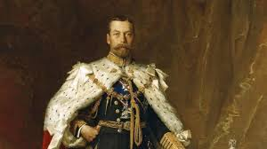

The intuitive distinction between a priori and a posteriori knowledge is best seen in examples.
A posteriori: George V reigned from 1910 to 1936." This is something that (if true) one must come to know a posteriori, because it expresses an empirical fact unknowable by reason alone.
A priori By contrast, consider the proposition, "If George V reigned for at least four days: then he reigned for more than three days." This is something that one knows a priori, because it expresses a statement that one can derive by reason alone.

1. What is an argument?
Philosophy is concerned with arguments – their construction, analysis, support and rejection – but how do we determine exactly what is and what is not an argument? How do we assess whether an argument is valid or not? How do we work out if we can agree, or not, with an argument?
What is an argument?
We can determine whether a passage contains an argument by asking whether it contains any claims that are being supported or defended. The sentences that provide – or are intended to provide – the support to a claim are called the premises of the argument. All arguments, by definition, must contain at least one premise and one claim.
Consider the following:
1. Tomorrow’s lecture will be on Kant. It’s the last lecture of the semester, and last year this professor chose Kant as his topic for his final lecture.
The speaker is making an ordinary prediction about what will happen at some future time (in this case, ‘tomorrow’). The prediction, however, takes the form of an argument, which is simply to say that the prediction amounts to a claim with some reason or evidence (a premise) given in support of it. Formally, it can be broken down in this way:
Claim: Tomorrow’s lecture will be on Kant.
Premise: The same professor gave a lecture on Kant at the same point in time in last year’s course.
What links the claim to the premise is an inference. Inference in ordinary language is often signalled by a connecting word after the claim such as ‘because’, or if the premises are stated before the claim, ‘so’ or ‘therefore’:
i. Tomorrow’s lecture will be on Kant because it’s the last lecture of the semester and Dr Burke chose Kant as the topic for his final lecture last year.
ii. It’s the last lecture of the semester, and last year Dr Burke chose Kant as the topic for his final lecture. Therefore, tomorrow’s lecture will be on Kant.
However, when we break down or analyse an argument’s structure, we usually leave the connecting words out.
For now, compare 1 above, with 2 below:
2. I’m really bored. Every week is just the same. Study, study and more study.
Our teenage angst might well be used as a prelude to an argument – a persuasive appeal for a study break or extra allowance might easily follow – but barely stated, it offers nothing to trouble the disinterested parent simply because sentence 2 fails to amount to an argument. The speaker is not here trying to establish or support a claim of being bored. Rather, he is reporting that he is bored and offering an explanation for it.
One way to think of the difference between a claim and other language functions such as reports, descriptions and explanations is to say that a claim must, at least in principle, be capable of being either true or false. The statement ‘I’m really bored’, so long as it is not spoken in jest or insincerity, does not seem capable of being false in quite the same way that the claim in sentence 1 is capable of being false. That is to say, ordinarily, we would not expect a speaker to be mistaken or to turn out to be wrong or ignorant about their own immediate feelings.
The sentence in 3 below also fails to be an argument, but for a different reason:
3. If God exists, then atheism is false.
This kind of sentence is called a closed conditional. It is a statement of the relationship between a limited number of possibilities (in this case, two), where all the possibilities are covered, so the conditional sentence remains logically true no matter what is, as a matter of fact, the case. We say it is closed and remains logically true because even in a world where God were proven not to exist, it would still be true that if God had existed or ever would exist in that world, then atheism would be false. Thus, the sentence 3 is true regardless of whether God exists or not (later, we will learn that 3. is an example of a wider species of statements called ‘tautologies‘).
Open conditionals are ‘if…then’ statements that leave some options out of the statement:
4. If God exists, Jesus was the son of God.
It could be the case that God exists, but still false that Jesus was his son; hence, the conditional is said to be open. Even so, an open conditional barely stated does not amount to an argument if it contains no premise or supporting reason to justify its belief or acceptance. A claim without any premises or supporting reasons for its acceptance is called a statement or assertion and is much like our report of teenage boredom in sentence 2, which is to say it fails to be philosophically interesting.
Conditionals, open or closed, do not on their own make arguments, but they can make claims and premises. Sentence 4 could be a claim if it were backed up with some supporting reason.
Here’s an example of an argument that use conditionals in both its premises:
5. Life on Earth is in peril. If we had not burned so much fossil fuel in the late 20th century, there would not have been so much carbon dioxide in the atmosphere. If there were less carbon dioxide in the atmosphere, the greenhouse effect would not be running out of control.
The form of the argument is:
Claim: Life on Earth is in peril.
Premise 1: If we had not burnt so much fossil fuel in the late 20th century, there would not have been so much carbon dioxide in the atmosphere.
Premise 2: If there were less carbon dioxide in the atmosphere, the greenhouse effect would not be running out of control.
REVIEW
• An argument must contain both a claim and one or more premises.
• A claim without any premises is called an assertion or statement.

Exercise 1
Each of the following contains an argument. Identify the premises and conclusions. Note thatnot all the sentences in an argumentative passage need be either a premise or a conclusion. Often, when we present an argument, we include comments that play no argumentative role.
a.
I had a lecture with Professor Jones this morning. He must have a cold. He was coughing throughout the whole lecture.
Claim:
Premise:
b.
Nation-state politics makes solutions to global problems impossible to achieve. If we continue to bicker over policies concerning global problems, it will soon be too late to do anything about them. Therefore, we must start negotiating towards the establishment of a world government.
Claim:
Premise 1:
Premise 2:
c.
If Mill is wrong, then Kant could be right, and if Aristotle is wrong we will have to reconsider Plato. That’s a real worry. Since it seems sure that either Mill or Aristotle is wrong, it looks as if we will either have to reconsider Kant or reconsider Plato.
[*Notice that the claim and all the premises are open conditionals.]
Claim:
Premise 1:
Premise 2:
Premise 3:
d.
Everybody is free to make their own health and diet choices. Any kind of food, not just fast food, can be dangerous if eaten excessively. This is common sense. Therefore, people do not need to be told what to eat.
Claim:
Premise 1:
Premise 2:

2. Hidden premises
Often, premises are implicit or hidden in an argument. This means they are not mentioned but are assumed – knowingly or unknowingly – by the speaker or writer. Reconsider example 5 from the previous post:
5. Life on Earth is in deadly peril. If we had not burnt so much fossil fuel in the late 20th century, there would not have been so much carbon dioxide in the atmosphere. If there were less carbon dioxide in the atmosphere, the greenhouse effect would not be running out of control.
In fact, this argument only works if we assume the truth of another premise, namely, that ‘When the greenhouse effect runs out of control, life on earth is in deadly peril’. Often, hidden or implicit premises like these are not mentioned simply because they are obvious.
Here’s another argument with an implicit premise:
6. H₂O is abundant on Earth. 70% of the world’s surface area is water.
The implicit premise is that H₂O and water are the same thing, but why mention something in an argument which no one finds controversial? It would be tiresome to have to mention everything presupposed by an argument’s conclusion when most of it is not in dispute. That being said, however, it is essential that the philosophy student realises that hidden premises are particularly important precisely because in complex arguments on controversial issues, there are often implicit premises that may not be recognised by one or more parties. What is more, it is these that often turn out to be the very premises which are responsible for the controversy. Here is a good example:
7. Murder is always wrong. Even though the state sanctions capital punishment, clearly capital punishment is wrong.
The claim in this argument cannot be established unless one agrees to the hidden premise that ‘capital punishment is murder’. Whether one agrees with the argument’s claim that ‘capital punishment is wrong’ will turn precisely on this hidden – and controversial – premise rather than on the two uncontroversial stated ones.
If you think carefully about any argument, you will almost always find a hidden premise. This is because speakers and writers usually have a common background with their audience, so that some information is unnecessary to mention. However, you should always think about hidden premises and weigh up whether they are significant or not. The argument in 7. has many implicit premises including, for example, ‘the State has the power to punish people’. However, this is not significant because it is irrelevant to establishing the claim – it makes no difference to the argument one way or the other.
REVIEW
• All philosophically-interesting arguments contain hidden premises
• Hidden premises need to be recognized and assessed as to their significance

Exercise 2

Suggest a significant hidden premise (or assumption) in the following arguments:
a.
If it rains we will get wet. If it snows we will get cold. Thus, we will either get wet or cold.
Your answer:
________________________________________________________
b.
Every event has a cause. Human actions are events. Therefore, every human action is determined by past events.
Your answer:
________________________________________________________
c.
All you need to produce Artificial Intelligence is to discover the particular type of computational processes that lead to consciousness.
Your answer:
________________________________________________________
d.
Human behaviour is determined by genetics not social conditioning. Clearly, if the authorities brought in a rule banning growing hair, we would all be imprisoned. Likewise, a ban on ‘being hungry’ or ‘being thirsty’ would be unenforceable. Social conditioning cannot override our genetic inheritance.
Your answer:
________________________________________________________
e.
Many people argue that testing drugs on animals is cruel. In some cases this is true. However, it would be much crueller to test new drugs on people or children or to let people die because there was not enough research on a new drug.
Your answer:

________________________________________________________

Philosophy & Ethics A Level

A Level Philosophy of Religion (G571)
Philosophy is simply “thinking about thinking”, an intellectual journey of life.
At AS we study Ancient Greek philosophers Plato and Aristotle. We then look at arguments for and against the existence of God. This involves the study of many philosophers including Kant, Descartes, Dawkins and Aquinas.
We start off looking at the Ancient Greek influences on Philosophy of Religion. To be prepared to start this you need to distinguish between the main approaches to knowledge:
Rationalism – Rationalist philosophers believe that all knowledge can be understood through a process of reasoning, without any external sources.
Empiricism – In philosophy, empiricism is a theory which believes that all knowledge comes from experience.
Compulsory Tasks – Work to be handed to teacher FIRST LESSON BACK
- Research the TWO main approaches to knowledge and produce a summary of each. You should include particular philosophers, and link these to Plato or Aristotle.
- Read and summarise the main points made in Plato’s Allegory of the Cave

  - http://faculty.washington.edu/smcohen/320/cave.htm
  - https://youtu.be/69F7GhASOdM?t=87
  - http://classics.mit.edu/Plato/republic.8.vii.html
- Read and summarise the main points made by Aristotle in his Metaphysics, Book 12
  - http://www.the-philosophy.com/aristotle-metaphysics-summary
  - http://classics.mit.edu/Aristotle/metaphysics.12.xii.html
  - https://www.youtube.com/watch?v=V0LmZbeKU9k&t=103s
Recommended Reading
If you want to achieve a high grade in both AS and A2 then you need to be reading at a very high level. You need to engage with much more than just the textbook you are given (good though they are).
So you should aim to read AT LEAST ONE of the following books:
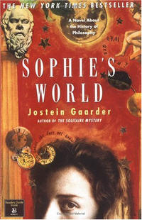
- Philosophy: The Essential Study Guide by Nigel Warburton ISBN 0415341809
- Philosophy: The Classics by Nigel Warburton ISBN 0415356296
- Sophie's World by Jostein Gaarder ISBN 1858815304

Philosophy & Ethics A Level

A Level Religious Ethics (G572)
Ethics is the part of philosophy that deals with good and evil. Ethics tries to answer questions like:
- What actions are good? What actions are evil?
- How can we tell the difference?
- Are good and evil the same for everyone?
- How do our actions affect others?
To be prepared for the study of ethics it is important to be able to distinguish between:
Deontological ethics – This is the branch of ethics concerned with actions. Here we should follow independent moral rules or duties. When we follow our duty, we are behaving morally. When we fail to follow our duty, we are behaving immorally.
Absolutist ethics – Some people think there are such universal rules that apply to everyone. This sort of thinking is called moral absolutism.
Teleological ethics – This is the branch of ethics concerned with consequences. Consequentialism teaches that people should do whatever produces the greatest amount of good consequences.
Relativist ethics – If you look at different cultures or different periods in history you'll find that they have different moral rules. So what is right or wrong depends on the situation.
Compulsory Tasks – handed to your teacher FIRST LESSON BACK:

- Research the FOUR main categories of ethical theory and produce a summary of each. You should include particular philosophers or ethical theories, and link these to examples of ethical dilemmas.
- Read and summarise AT LEAST ONE news article on each on the following areas of Applied Ethics:
  - Abortion
  - Right to a Child / Infertility Treatments
  - Euthanasia
  - Genetic Engineering / Medical Ethics
  - War and Peace
You should include the main ethical issue(s) raised in the article, and explain the arguments FOR and AGAINST the issue(s) mentioned.

Recommended Task – aiming for top marks you should read:

- Ethics Made Easy – Mel Thompson ISBN 1444123033

Advisable:
Read or watch AT LEAST ONE of these:
The Cider House Rules (John Irving – abortion) | Million Dollar Baby (Euthanasia)
Birdsong (Sebastian Faulks – War) | My Sister’s Keeper (Genetic Engineering)
Brave New World (Genetic Engineering) | Gattaca (Genetic engineering)
2184 (Martin Parish – genetic engineering) | Never Let Me Go (Cloning)

